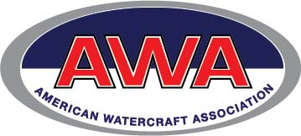

August 6, 2018

Dear AWA Member,
In 2010, a fringe environmental group sued the National Park Service (NPS) at Gulf Islands National Seashore claiming personal watercraft should be prohibited on these publicly owned waters. This forced the NPS to spend $652,000 of your tax dollars on a revised Environmental Impact Statement (EIS) and new draft PWC Management Plan.
Both documents were released last week. It’s essential our voices are heard. The NPS is holding a series of public hearings where your attendance and input are vital. We understand that attending hearings on a weeknight is difficult and time consuming. Yet it’s essential to stand up for your access to your public waterways. If you don’t speak up, the anti-access crowd wins.
Please gather fellow riders, family and other boaters and attend one of these critical public hearings. These waters belong to everyone – not just a chosen few.
These public meetings will be held in Florida and Mississippi the week of August 20. All meetings run from 4 p.m. to 7 p.m.
Tuesday, August 21: Park Headquarters, 1801 Gulf Breeze Parkway, Gulf Breeze, FL 32563
Wednesday, August 22: Perdido Key Community Center, 15500 Perdido Key Drive, Pensacola, FL 32507
Thursday, August 23: Davis Bayou Visitor Center, 3500 Park Road, Ocean Springs, MS 39564
The AWA supports Alternative B – Personal Watercraft should be able to operate just as any other motorized vessel.
The NPS prefers Alterative D, which would still discriminate against personal watercraft. The other alternatives range from an outright ban, to unjust discriminatory restrictions.
If you are unable to attend one of these important public hearings, your voice still counts: Please submit a public comment supporting Alternative B at the following address: https://parkplanning.nps.gov/projectHome.cfm?projectID=40970
Public comments close September 17th, 2018. Make sure fellow PWC riders, family, friends and like-minded boaters submit a comment supporting Alt B. Your opinion counts. The NPS works for all of us. If possible, attend a meeting and submit a comment. Numbers count.
Make copies of this letter and distribute them to fellow riders. Every rider has a stake in this basic freedom of access issue. Comment today, and plan on attending a public hearing. Your access to your public waters depends on it.
Think Free. Live Free. Ride Free.
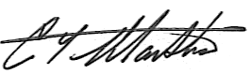
Chris Manthos, American Watercraft Association

